|  |
| --- |
| FAST National University |
|  |
|  |

**Computer Organization and Assembly Language**

|  |  |
| --- | --- |
| **Student Name** | Moeez Ali |
| **Registration #** | 21L-1798 |
| **Instructor** | Hazoor Ahmad |
| **Class** | CS3 |
| **Section** | 3 G |
| **Semester** | Fall 2022 |

Fast School of Computing

FAST-NU, Lahore, Pakistan

# Activity 1

## **Assembly Language Code**

[org 0x100]

jmp start

msg1: db 'Hi! I am Moeez.',0

msg2: db 'I am very happy',0

msg3: db 'I Study at FAST_NUCES.',0

msg4: db 'My Roll No is 21l-1798',0

clrscr:

push ax

push es

push cx

push di

mov ax,0xb800

mov es,ax

xor di,di

mov ax,0x0720

mov cx,2000

rep stosw

pop di

pop cx

pop es

pop ax

strlen: push bp

mov bp,sp

push es

push cx

push di

les di, [bp+4]

mov cx, 0xffff

xor al, al

repne scasb

mov ax, 0xffff

sub ax, cx

dec ax

pop di

pop cx

pop es

pop bp

ret 4

printstr: push bp

mov bp, sp

push es

push ax

push cx

push si

push di

push ds

mov ax, [bp+4]

push ax

call strlen

cmp ax, 0

jz exit

mov cx, ax

mov ax, 0xb800

mov es, ax

mov al, 80

mul byte [bp+8]

add ax, [bp+10]

shl ax, 1

mov di,ax

mov si, [bp+4]

mov ah, [bp+6]

cld

nextchar: lodsb

stosw

loop nextchar

exit: pop di

pop si

pop cx

pop ax

pop es

pop bp

ret 8

*;______________________________________________________________________________________*

start: mov ah, 0x10

mov al, 03

mov bl, 01

int 0x10

mov ah, 0

int 0x16

call clrscr

mov ah, 0

int 0x16

mov ax, 20

push ax

mov ax, 1

push ax

mov ax, 02

push ax

mov ax, msg1

push ax

call printstr

mov ah, 0

int 0x16

mov ax, 20

push ax

mov ax, 2

push ax

mov ax, 02

push ax

mov ax, msg2

push ax

call printstr

mov ah, 0

int 0x16

mov ax, 20

push ax

mov ax, 3

push ax

mov ax, 02

push ax

mov ax, msg3

push ax

call printstr

mov ah, 0

int 0x16

mov ax, 20

push ax

mov ax, 4

push ax

mov ax, 02

push ax

mov ax, msg4

push ax

call printstr

mov ah, 0

int 0x16

mov ax, 0x4c00

int 0x21

## **Debugging Screenshots**

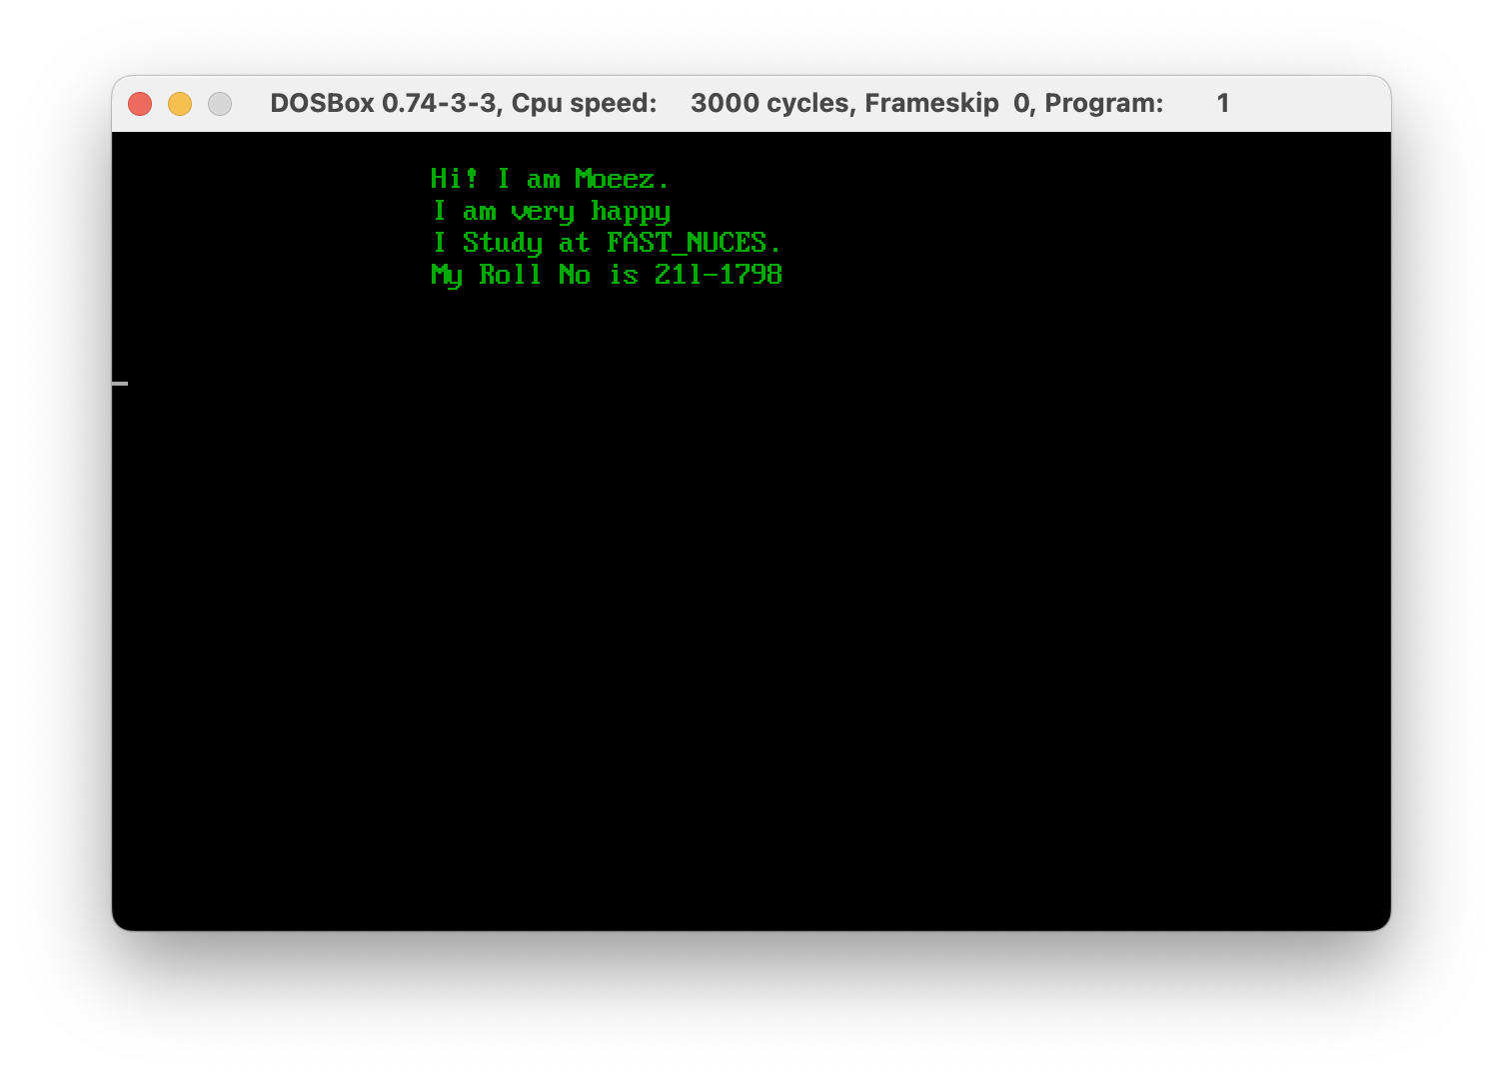

# Activity 2

## **Assembly Language Code**

[org 0x0100]

jmp code

w equ 50 *; width offset*

x equ 50 *; starting x coordinate of line*

y equ 100 *; starting y coordinate of line*

c equ 70 *; color*

a equ 150

b equ 100

e equ 100

d equ 50

code: mov ah, 0

mov al, 13h

int 10h

*; draw diagonal 11:*

mov cx, x

mov dx, y

mov al, c

u1: inc dx

mov ah, 0ch *; put pixel*

int 10h

inc cx

cmp cx, x+w

jbe u1

*; draw diagonal 12:*

mov cx, b

mov dx, x

mov al, c

u2: inc dx

mov ah, 0ch *; put pixel*

int 10h

dec cx

cmp cx, 50

jge u2

*; draw diagonal 11:*

mov cx, a

mov dx, b

mov al, c

u3: inc dx

mov ah, 0ch *; put pixel*

int 10h

dec cx

cmp cx, a-w

jge u3

*; draw diagonal 11:*

mov cx, e

mov dx, d

mov al, c

u4: inc dx

mov ah, 0ch *; put pixel*

int 10h

inc cx

cmp cx, e+w

jbe u4

*;wait for keypress*

mov ah,00

int 16h

mov ax, 0x4c00

int 21h

## **Debugging Screenshots**

